**9 Build Chemistry - Quick Quiz 1**

Name: ___________________________________

**How much do you know and understand? Answer each question to the best of your ability.**

1. Use the terms below to correctly label the diagram of the atom.

|  |  |  |  |  |
| --- | --- | --- | --- | --- |
| electron | proton | neutron | nucleus | shell |

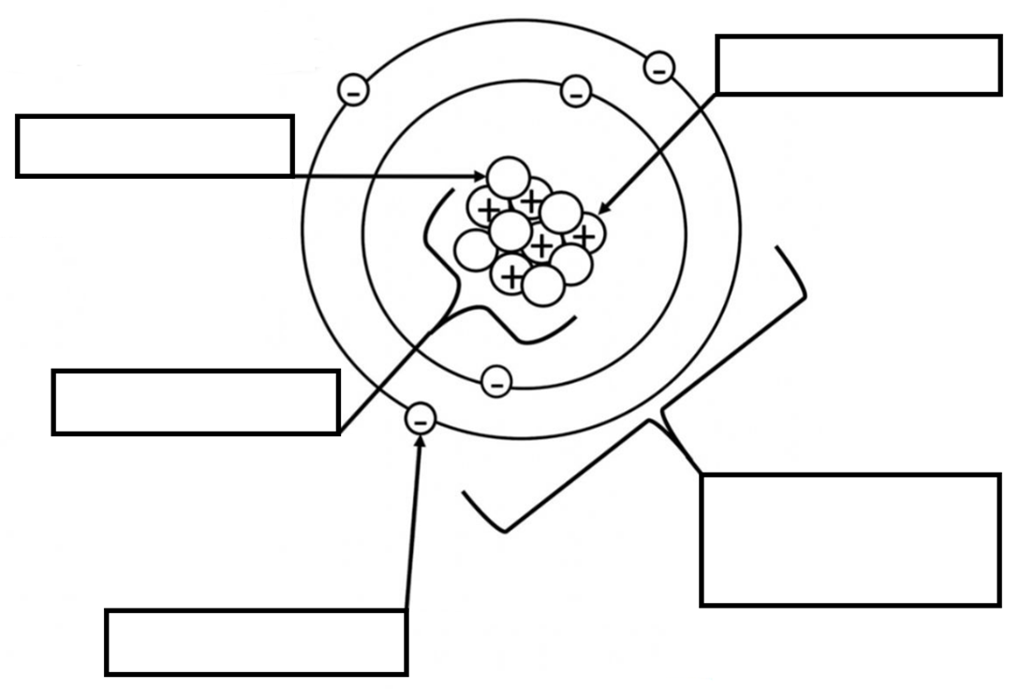

1. Use the information in the element square on the right to determine the:

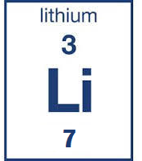

* 1. Atomic number _____________
  2. Mass number _____________
  3. Number of neutrons ____________

1. Match the correct term with each definition

|  |  |  |
| --- | --- | --- |
| **Term** |  | **Definition** |
| Mixture |  | The smallest particles of an element that are the building blocks of matter. |
| Atom |  | Two or more different elements chemically combined. |
| Element |  | Two or more substances not chemically combined. |
| Compound |  | A pure substance consisting of only one type of atom. |

**The following multiple-choice questions refer to the diagram on the right.**

1. Which diagram(s) represents one type of compound?
   1. C
   2. C and D
   3. B
   4. D
2. Which diagrams represent elements?
   1. B, C and D
   2. C and D
   3. A and B
   4. A, B, C and D
3. Which diagram(s) represents a mixture?
   1. B
   2. D
   3. C and D
   4. A and B